**Feature Extraction and Price Prediction for Mobile Phones:**

**Reports:**

The project of feature extraction and price prediction for mobile phones typically involves leveraging machine learning techniques to analyse various features of mobile phones and predict their prices. Here's a small overview of how such a project might be structured.

1. **Data Collection:** The first step involves gathering data on mobile phones, including their features and corresponding prices. This data can be collected from various sources such as online retailers, manufacturers' websites, or APIs provided by mobile phone databases.
2. **Feature Extraction**: Once the data is collected, the next step is to extract relevant features from it. Features could include specifications like processor type, RAM size, camera quality, battery capacity, display resolution, brand, etc. Feature extraction might also involve data preprocessing steps like handling missing values normalizing numerical features, and encoding categorical features.

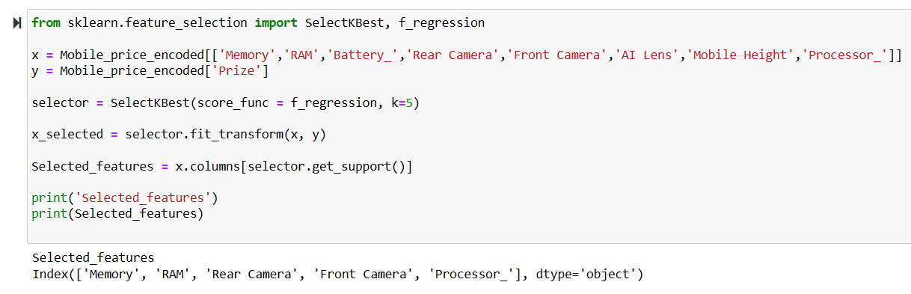

**Libraries:** It imports necessary libraries from sklearn for feature selection.

**Data Preparation:** Variables x and y are defined to hold encoded mobile price data and target values, respectively.

**Feature Selection:** A SelectKBest object named ‘selector’ is created to select the top 5 features based on the f_regression score.

**Output:** The selected features are ‘Memory’, ‘RAM’, ‘Rear Camera’, ‘Front Camera’, and ‘Processor’, which are printed out at the end of the snippet.

1. **Exploratory Data Analysis (EDA):** EDA is conducted to gain insights into the data and understand the relationships between different features and the target variable (price). Visualization techniques can be employed to identify patterns, correlations, and outliers in the data.
2. **Model Building:** After feature extraction and EDA, the data is divided into training and testing sets. Various machine learning algorithms such as linear regression, decision trees, random forests, or gradient boosting can be employed to build predictive models. These models learn the relationship between the features of mobile phones and their prices from the training data.

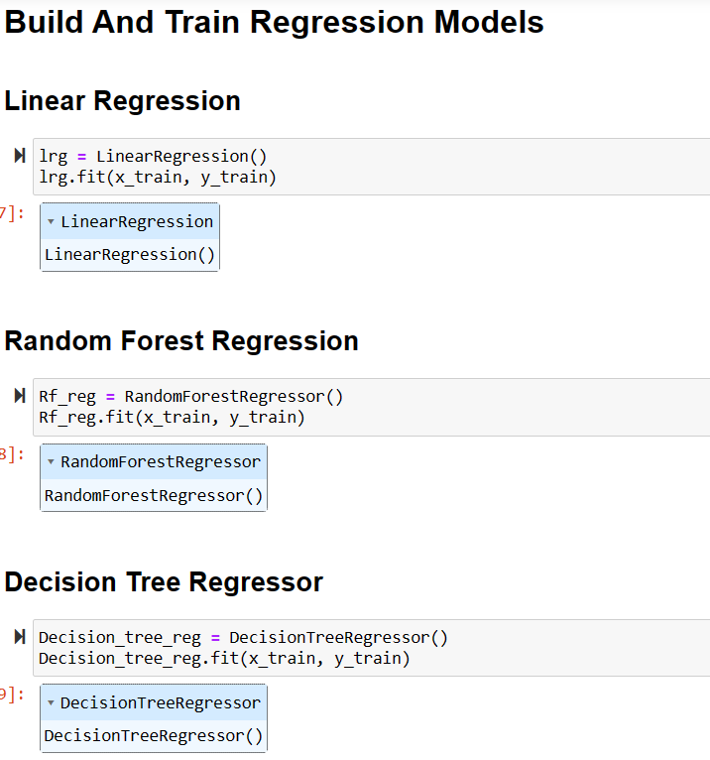

1. **Model Evaluation:** The trained models are evaluated using appropriate evaluation metrics such as mean squared error (MSE), mean absolute error (MAE), or R-squared to assess their performance on the testing data. Cross-validation techniques may also be applied to ensure the robustness of the models.

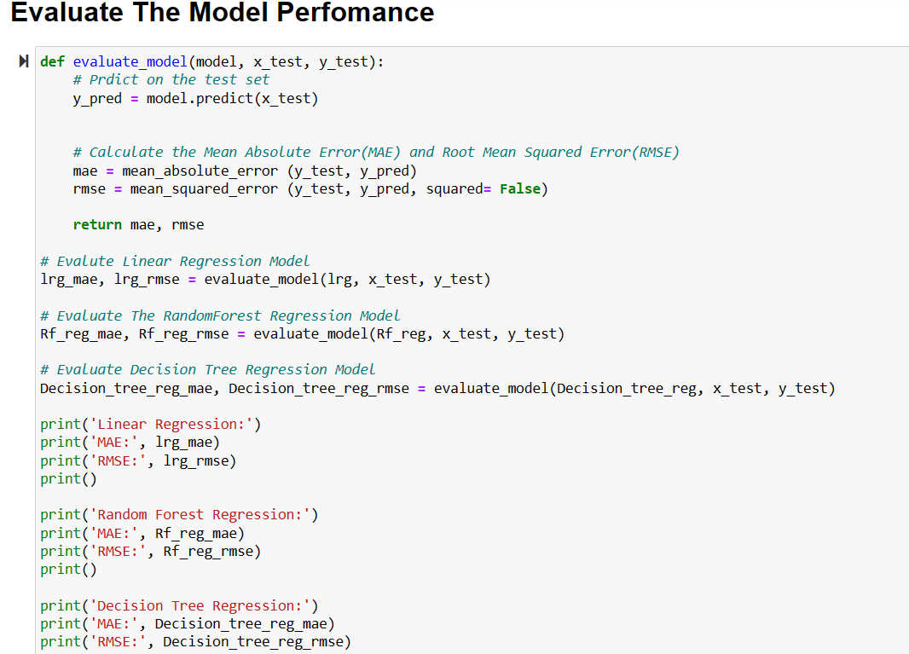

**Function Definition:** A function evaluate_model is defined to predict on the test set and calculate Mean Absolute Error (MAE) and Root Mean Squared Error (RMSE).

**Model Evaluation:** The Linear Regression, Random Forest Regression, and Decision Tree Regression models are evaluated, with their MAE and RMSE printed out.

**Code Comments:** Comments are included within the code to explain the purpose of each section.

1. **Price Prediction:** Once the models are trained and evaluated satisfactorily, they can be used to predict the prices of mobile phones based on their features. Users can input the specifications of a mobile phone, and the model will output an estimated price.

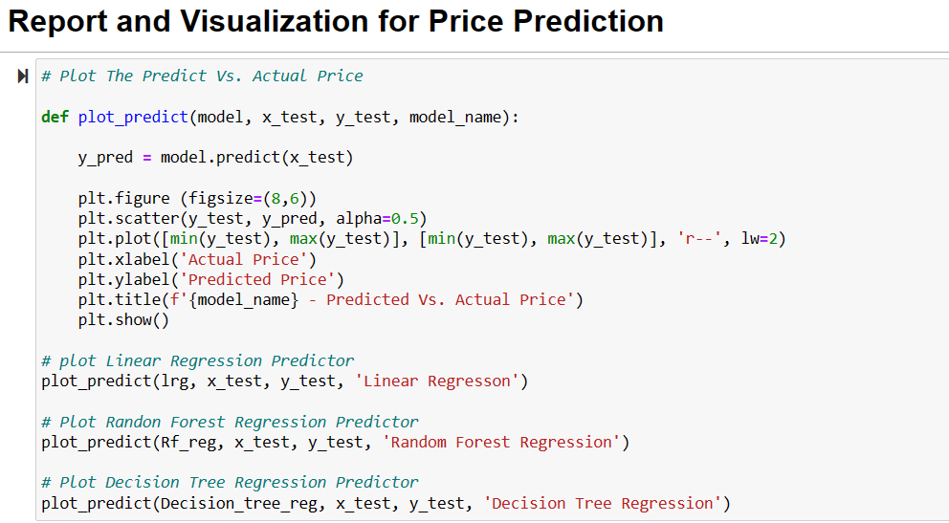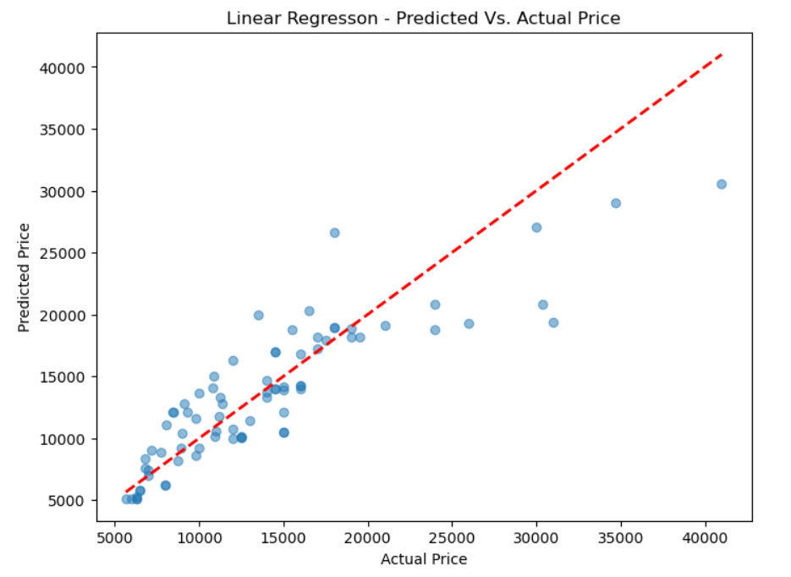

**Data Points:** Blue dots represent actual data points, showing the relationship between the actual and predicted prices.

**Prediction Model:** A red dashed line indicates the linear regression prediction, suggesting a good fit for lower price ranges.

**Axes:** The x-axis shows the Actual Price, and the y-axis shows the Predicted Price, both ranging from 5000 to 40000.

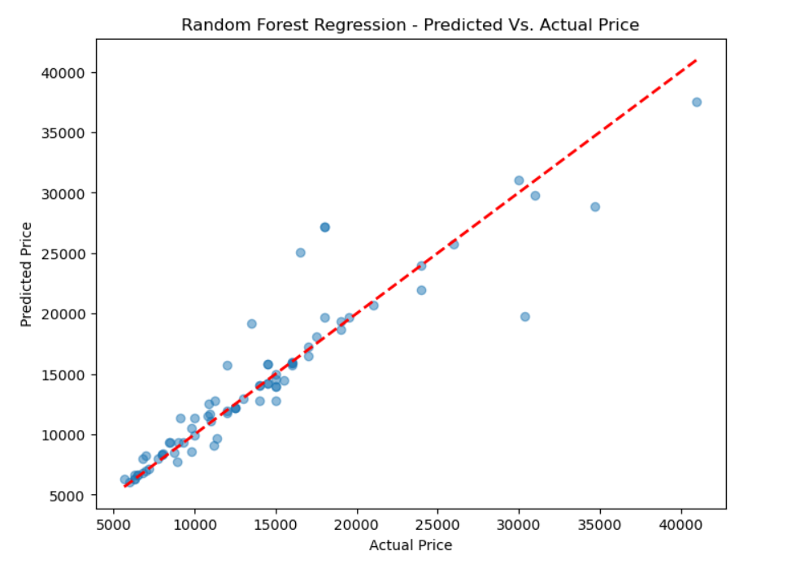

**Graph Type:** Scatter Plot

**Purpose:** To compare predicted prices from a Random Forest Regression model against actual prices.

**Axes:** The x-axis shows actual prices, and the y-axis shows predicted prices, both ranging from 5,000 to 40,000.

**Data Points:** Represented by blue dots, clustered near the red dashed line indicating accurate predictions.Ideal Prediction: The red dashed line represents a perfect prediction where the predicted price equals the actual price.

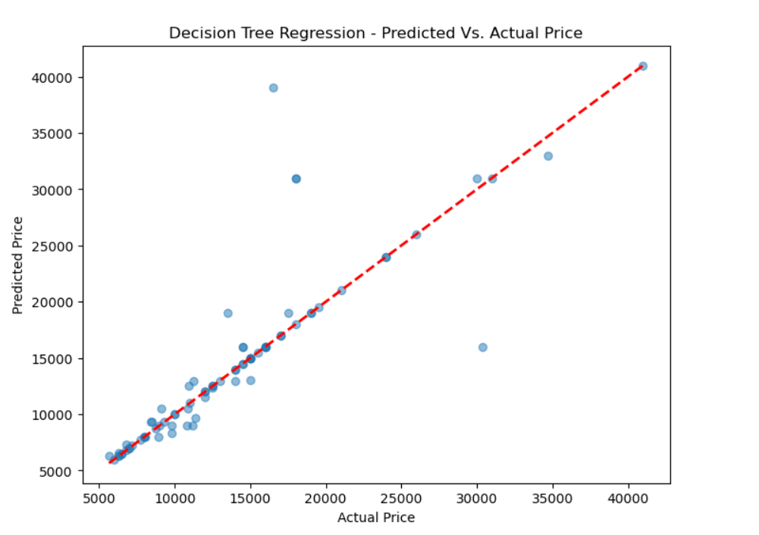

**Actual vs. Predicted:** The x-axis shows the actual prices, and the y-axis shows the predicted prices, both ranging from 5000 to 40000.

**Accuracy Indicator:** The red dashed line represents where the predicted price equals the actual price, serving as a benchmark for perfect prediction.

**Data Points:** Blue dots scattered around the red line represent individual predictions, with most dots close to the line indicating a high accuracy of the model’s predictions.

1. **Conclusion:** In summary, the project of Feature Extraction and Price Prediction for Mobile Phones showcased the application of machine learning techniques to analyse mobile phone features and predict their prices. By collecting data from various sources and extracting relevant features, such as processor type, RAM size, and camera quality, the project laid the foundation for accurate price predictions. Through exploratory data analysis and model building, including the evaluation of linear regression, random forest regression, and decision tree regression models, it was demonstrated that these techniques could effectively capture the relationship between mobile phone specifications and their prices. The visualizations provided insights into the accuracy of the predictions, indicating promising results. Overall, the project highlights the potential of machine learning in informing pricing decisions in the mobile phone industry.

Thank You.